Amy L. Ai, PhD

Florida State University

2570 University Center Building-C

Tallahassee, FL 32306

(850) 644-3577

amyai8@gmail.com

February 8 2024

Richard Norton, MD

Editor-in-Chief, The Lancet

[richard.horton@lancet.com](mailto:richard.horton@lancet.com)

Dear Dr. Norton,

Please find the manuscript, titled “*Association of Posttraumatic Growth with Covid-19 and Posttraumatic Stress: A Meta-analytic Review,*” uploaded to The Lancet submission site. We hope that itbe considered for review by your editorial board. The manuscript has not been previously published nor is it under consideration at another outlet; furthermore, the findings have not been posted online.

We assume that the finding will be of interest to the readers of The Lancet because this interdisciplinary study provides information on an aggregated outcome, PTG, in populations exposed to the Covid-19 Pandemic, the deadliest global disaster in the 21 century. The under-investigated positive side of the major threat to humanity may have implications for patient-centered preventive and clinical care in coming decades.

All authors have contributed substantively to developing this manuscript and agreed to be a co-author. The authors declare that there are no conflicts of interest. Because this first meta-analysis on this topic in the context of Covid-19 use only published data, the human subject application is not relevant. We do not know which sub-journal under the system of The Lancet will be suitable for this topic. But we trust that you will direct it to the appropriate one.

To make the manuscript short, all subgroup figures are in the Appendix for provision upon request. If you consider that they are acceptable within the desirable length, we can put it back. One more issue, there are more citations than the # in one of the limit instructions. But, our text is several hundred below the word limit. If RR is granted, we are willing to cut more on requests.

Thank you for your attention! We look forward to hearing your editorial decision.

Amy L. Ai, PhD

FSU Distinguished Research Professor

**Association of Posttraumatic Growth with Covid-19 and Posttraumatic Stress:**

**A Meta-analytic Review**

Amy L. Ai, PhD1

Qizhou Duan, MS2

Marguerite Rwil, UROP RA3

Henry Carrett, PhD, MPH34

**(Running Head: Covid-19 and PTG)**

(02/06/2024, in Submission to The Lancet)

### 1. Corresponding author: Distinguished Research Professor, Colleges of Social Work, Medicine (Social Medicine and Behavioral Science), and Nursing, 2570 University Center Building C, Florida State University (FSU), Tallahassee, FL, 32306; amyai8@gmail.com2.

2. Department of Psychology, University of Notre Dame, qduan@nd.edu

3. Undergraduate Research Assistant, msr21b@fsu.edu

4. Colleges of Social Work, Medicine (Social Medicine and Behavioral Science), FSU, hjcarret@gmail.com

***Authors’ note:*** …..

**Association of Posttraumatic Growth with Covid-19 and Posttraumatic Stress:**

**A Meta-analytic Review**

**(Running Head: Covid-19 and PTG)**

(02/06/2024, in Submission to The Lancet)

***Acknowledgement:*** All Authors have contributed to sustentive development of this research and writing and agreed to be a co-author of this manuscript.

***Sources of Fundings:*** None.

***Disclosures:*** None.

***The total word count of the manuscript***: Title Page: ?? Words, Abstract: ?? Words, Text: ?? Words, References: ?? Words, Cannot add figure/legend information as they are screengrabs)

**Abstract: Background**. Posttraumatic growth (PTG), positive gains arising from the struggle with trauma, can be easily assessed and may lead to optimal outcomes of patients, health providers, and general populations affected by Covid-19. This is the first meta-analysis and systematic review of the association between PTG and Covid-19 and posttraumatic stress symptoms (PTSS). **Method.** PubMed (30), PsychINFO (6), Academic Search Complete (4), Ovid MEDLINE (20), electronic databases were systematically searched from May 23, 2023 through January 8, to identify all eligible studies reporting the association between PTG and Covid-19 by suing the following Medical Subject Heading and psychological terms: Covid-19, posttraumatic growth, PTG, stress-related growth, adverse growth, positive outcomes, positive effects, self-growth. Data were screened and extracted independently by 2 investigators. Adjusted effect estimates were employed, and pooled analysis was conducted, using the Hartung-Knapp-Sidik-Jonkman rondom-effects model. Sensitivity and subgroup analyses were conducted to assess the robustness of the findings. The Meta-analysis of Observational Studies in Epidemiology (MOOSE) reporting guideline was followed. **Results.** The search yielded 60 unique publications around the globe, of which 42 qualified for full-text review. **Results.** The final selection involved a composite of 30 studies with data on the COVID-19—PTG association, comprising 42, 386 participants. On pooled analysis, COVID-19 was significantly associated with PTG as determined mostly by Posttraumatic Growth Inventory (PTGI) (*g*=0.75; 95%CI, 0.45-1.05; *p*<.0001), with a high heterogeneity in the analysis (*I*2=99.72%). Subgroup analyses indicated no significant associations between Covid-19 related PTG and risk and protective factors (PTSD, depression, social support, coping, and spirituality). **Conclusion.** The findings indicate that COVID-19 events could be associated with PTG as a potential positive outcome. No test risk and protective factors might moderate this relationship. Future investigation should pursue more prospective design and explore the biobehavioral mechanisms underlying this relationship to promote PTG-related better outcomes in patient-centered care. (300 words + four subtitles).

***Keywords:*** Meta-analysis and systematic review, cardiovascular disease (COVID-19), post-traumatic growth (PTG), myocardial infarction, stroke, cardiac procedures

**Key Points**

**Question** Is Covid-19 potentially associated with posttraumatic growth among patients, health care providers, and general population globally exposed to the deadly pandemic?

**Findings** In this meta-analysis 30 studies including 42, 386. individuals, PTG was associated with individuals exposed to Covid-19 in both medical settings and beyond; the pooled association was consistent with that of findings from studies with diverse populations.

**Meaning** The findings suggest that an optimal outcome, posttraumatic growth, could occur among various populations affected by Covid-19 and that attention to this positive side of this global existential threat may be important for mental and public health during the pandemic.

**Introduction**

Since the World Health Organization declared the 2019 novel coronavirus (Covid-19) as a global emergency(Sohrabi_et_al.,2020), the pandemic has created a sweeping impact on mortality and detrimental psychiatric consequences(O’Connor_et_al.,2020;Wang_et_al.,2022). Unlike other severe diseases (e.g., cardiovascular diseases, cancer), Covid-19’s effect is pervasive and traumatic, influencing many sectors of populations(Krishnamoorthy_et_al.,2020) and at all levels (individual, family, community, nation, and the word). In medical settings, its highly contiguous nature also generatYed health and existential threats to both patients and health-care providers(Adjorlolo_et_al.,2022;Castiglioni_et_al.,2023;Chen_et_al.,2021;Khattab_et_al.,2020;Lewis_et_al.,2022;Yeung_et_al.,2022;Zhang_et_al.,2021).

Because of exposure to COVID-19, psychiatric stress and alter human cognition (e.g., negative thoughts or views of the world) could rise as do following other traumas(Moreland_et_al.,2023). However, positive cognition, such as posttraumatic growth (PTG), can also emerge with struggles as trauma-related psychological gains (e.g., positive mindset changes in cognition and worldview)(Calhoun_&_Tedeschi,2006). Most observed domains of PTG involved greater positive changes in personal strength, appreciation of life, and social relationships. PTG is also a kind of better outcomes in patients with life-altering diseases(Ma_et_al.,2022;Pięta_&_Rzeszutek,2022;Sawyer_et_al.,2010;Shand_et_al.,2015;Wang_et_al.,2022). A few meta-analyses have associated this phenomenon with low mortality in non-pandemic patients(Ma_et_al.,2022;Wan_et_al.,2023).

Given the long-term and vast impact of Covid-19(Emek_et_al.,2021;Parums,2021), it is necessary to examine if PTG cooccur with this pandemic as a modifiable dimension of outcomes in the United States and globally. In 2021, a national representative study of US veterans reported moderate to greater levels of PTG resulting from the COVID-19 experience, especially among those suffering from posttraumatic stress symptoms (PTSD) linked with positive Covid-19 results(Pietrzak_et_al.,2021). Other studies have also shown the emergence of Covid-19-related PTG in different countries. To provide more reliable and robust conclusion on this positive worldview-based mindset change across different sectors of populations (general populations, health-care providers, and infected patients), we conducted this first meta-analytic review to examining PTG during and post COVID-19.

A meta-analysis on another pandemic has demonstrated the relationship between PTG and adjustment among individuals living with HIV/AIDS(Pięta_&_Rzeszutek,2022). Yet, there is a lack of similar pooled analysis on the observed PTG in recent major pandemics. The paucity implies that more meta-analyses will be desirable for this optimal outcome in future medical research. Accordingly, this study employed a systematic approach to synthesize empirical studies in the United States and around the world. We aimed to reach a more creditable conclusion for an urgent question: Whether PTG could be observed globally under the threat of COVID-19 to mankind. More specifically, we evaluated the magnitude and consistency of the pandemic related PTG, as a change in posttraumatic positive cognition. We also conducted subgroup analyses linking PTG with certain risk and protective factors.

# **Methods**

# **Data Sources and Searches**

This systematic meta-analytic review was conducted and presented following the recommendations of the Meta-analysis of Observational Studies in Epidemiology (MOOSE) reporting guideline(Stroup_et_al.,2000). A systematic literature search of Ovid MEDLINE, PsycINFO, Academic Search Complete, and PubMed was performed for research articles published from 2000 since the first year of Covid-19, to January, 2024. The following Medical and Psychological Subject Heading terms were used to identify studies that assessed PTG in patients with COVID-19: posttraumatic growth, stress-related growth, adverse growth, COVID-19 MI, positive effects, positive outcome and self-growth. Furthermore, references from selected studies and relevant review articles were reviewed to identify additional publications(Cui_et_al.,2021;Feingold_et_al.,2022;Finstad_et_al.,2021;Hyun_et_al.,2021;Kowalski_et_al.,2021;Li_et_al.,2022;Van der Hallen_&_Godor_et_al.,2022).

# **Study Selection**

Identified articles were in English, though no language restriction was used to cover publications in both the United States and abroad. Two investigators (A.A., Q.D) independently reviewed the potential candidates for this review. Eligible studies were original empirical research articles that assessed posttraumatic and adulthood growth related terms in different types of people who had various with the global pandemic (e.g., patients, health providers, community dwellers, etc.). Studies on other pandemic only (e.g., Ebola, influenzas) or other disasters were excluded. Then, for the purpose of uniformity of measure, we decided to adopt PTGI(Posttraumatic Growth Inventory;Tedeschi_&_Calhoun,1996) as the standard scale for measuring PTG. Any standard variants of PTGI (e.g., PTGI-SF) that could be converted to its scoring style were included. Stated differently, only those with mean scores on PTG with standard deviation or correlates with PTG were included.

Studies using open-ended measures were excluded due to the lack of validation. Studies that did not employ an established and validated scale that specifically focused on PTG, or used other types of measures for gains were excluded. Measures such as Stress-related growth scales(e.g., SRGS, Park,_Cohen,_&_Murch,1996) that were derived from a different set of items, and accesses different aspects of PTG, were excluded. The latter type of exclusion also involved measures on such broader positive changes as Benefit Finding Scale(Mohr_et_al.,1999) Perceived Benefit Scale(McMillen_&_Fisher.,1998), because certain gains did not pertain to adulthood growth.

**Data Extraction and Quality Assessment**

According to pre-planned protocol and using a standardized form, an assistant investigator (M.R.) reviewed all abstracts first to identify potential studies for inclusion. Full text articles were obtained for all eligible studies and were independently reviewed by two investigators (A.A., Q.D.). Disagreement on the selected studies were then discussed for finalizing the sample. Next, the second reviewer (Q.D.) extracted data from the selected studies. The following data were extracted: study characteristics (e.g., author, year of publication, sample size, study design), patient characteristics (e.g., age, sex, COVID-19 diagnosis), PTG assessment tools, the measures (e.g. PTGI) of PTG, and the standard deviation of the measures for each study. The quality of the selected studies was assessed using Meta-analyses of Observational Studies in Epidemiology Checklist(Zuuren_&_Fedorowicz,2016).

**Statistical Analysis**

R (version 4.3.1) was used to conduct the meta-analysis. The current study selected articles that reported the mean and standard deviation (SD) of PTG as assessed by the either PTGI (Tedeschi_&_Calhoun,1996) or its variants. The PTG scale used in this study (PTGI) involved summing up ratings across 21 self-reported questions, resulting in a possible score range of 0 to 105. The weighted mean of PTGI was used to identify the level of PTG on COVID-19 patients. To categorize the level of PTG, a cutoff point was established: scores below 45 indicated none to low levels of PTG, while scores of 45 or above indicated medium to high levels of PTG. This cutoff point was chosen based on its frequent usage in existing literature(Mazor_et_al.,2016;Naghavi_et_al.,2020;Taher_&_Allan,2020;Wall_et_al.,2023). The PTG scale used in this study (PTGI) involved summing up ratings across 21 self-reported questions, resulting in a possible score range of 0 to 105. The weighted mean of PTGI was used to identify the level of PTG on COVID-19 patients. To categorize the level of PTG, a cutoff point was established: scores below 45 indicated none to low levels of PTG, while scores of 45 or above indicated medium to high levels of PTG. This cutoff point was chosen based on its frequent usage in existing literature(Mazor_et_al.,2016;Naghavi_et_al.,2020;Taher_&_Allan,2020;Wall_et_al.,2023).

The aforementioned method of using predetermined cutoff point to categorize the level of PTG posits a clear criterion. If the PTG measure collected from the studies were significantly higher than 45 cut-off point, then, the association of PTG with COVID-19 was considered positive.

The current study used a random effect meta-analytical model for main analysis. Random effect model does not assume a single true effect size, but rather assumes a distribution of true effect sizes. This means ensures the flexibility to take the between-study variability/heterogeneity in effect sizes into account in the analysis.

**Results**

**Study Characteristics**

Figure 1 illustrates a flow diagram of the literature and related screening process. The search yielded 60 unique publications, of which 42 qualified for full-text review. In the end, 30 studies(Adjorlolo_et_al.,2022;Arnout_&_Al-Sufyani,2021;Bai_et_al.,2023;Barnicot_et_al.,2023;Castiglioni_et_al.,2023;Chasson_et_al.,2022;Chen_&_Tang,2021;Chen_et_al.,2020;Das_et_al.,2023;El-Khoury Malhame_et_al.,2023;Gul_et_al.,2023;Kalaitzaki_et_al.,2022;Kalaitzaki_et_al.,2023;Lan_et_al.,2023;Lau_et_al.,2021;Lewis_et_al.,2022;Lyu_et_al.,2021;Morales_et_al.,2023;Mo_et_al.,2022;Northfield_&_Johnston,2021;Tu_et_al.,2023;Ulset_&_von Soest,2022;Vazquez_et_al.,2021;Wang_et_al.,2023;Willey_et_al.,2022;Yao_et_al.,2023;Yeung_et_al.,2022;Yildiz, 2021;Zhang_et_al.,2021;Zhou_et_al.,2020), met the inclusion criteria for the main analysis. 12 studies were selected for subgroup analyses on PTSD citations of them (Arnout_&_Al-Sufyani,2021; Chen_&_Tang,2021;Chen_et_al.,2020;Das_et_al.,2023;El-Khoury Malhame_et_al.,2023;Lan_et_al.,2023;Lau_et_al.,2021;Lewis_et_al.,2022;Mo_et_al.,2022;Vazquez_et_al.,2021;Wang_et_al.,2023;Zhang_et_al.,2021). Of these 12 included in the analysis, all employed PTGI or its variants (e.g. PTGI-SF) to examine PTG. Twenty-Five were cross-sectional studies and 5 were prospective studies. For the selected studies involving a total of 42,386 individuals, table 1 and table 3 present their overall characteristics.

Among the studies included in the analysis, seven studies were performed in the United States (Chen_et_al.,2021; Morales_et_al., 2023; Northfield_&_Johnston,2021; Tu_et_al., 2023; Willey et

al.,2022;Zhang_et_al.,2021;Zhou_et_al.,2020), two in the United Kingdom(Barnicot_et_al.,2023;Lewis_et_al.,2022), one in Ghana(Adjorlolo_et_al.,2022), two from Greece(Kalaitzaki_et_al.,2022;Kalaitzaki_et_al.,2023) and from the European countries of Norway, Italy and Spain one study was found in each(Castiglioni_et_al.,2023;Vazquez_et_al.,2021;Ulset_&_von Soest,2022) five from the Middle Eastern countries of Turkey, Pakistan and Saudi Arabia, and Israel(Arnout_&_Al-Sufyani,2021;Chasson_et_al.,2022;Das_et_al.,2023;El-Khoury Malhame_et_al.,2023;Gul_et_al.,2023;Yildiz,2021), nine from China,(Bai_et_al.,2023;Chen_&_Tang,2021;Lan_et_al.,2023;Lau_et_al.,2021;Lyu_et_al.,2021;Mo_et_al.,2022;Wang_et_al.,2023;Yao_et_al.,2023;Yeung_et_al.,2022). Included articles involved a variety of different types of people such as patients and the general population(Adjorlolo_et_al.,2022;Arnout_&_Al-Sufyani,2021;Castiglioni_et_al.,2023;Chen_&_Tang,2021;El-Khoury Malhame_et_al.,2023;Gul_et_al.,2023;Kalaitzaki_et_al.,2022;Lau_et_al.,2021;Lewis_et_al.,2022;Northfield_&_Johnston,2021;Ulset_&_von Soest,2022;Vazquez_et_al.,2021;Willey_et_al.,2022;Zhou_et_al.,2020), nurses and medical doctors(Bai_et_al.,2023;Barnicot_et_al.,2023;Chen_et_al.,2020;Das_et_al.,2023;Kalaitzaki_et_al.,2023;Lyu_et_al.,2021;Mo_et_al.,2022;Yao_et_al.,2023;Yeung_et_al.,2022;Zhang_et_al.,2021), pregnant women(Chasson_et_al.,2022), and students(Lan_et_al.,2023;Morales_et_al.,2023;Tu_et_al.,2023;Wang_et_al.,2023;Yildiz,2021) most of which centered on the general population during COVID 19.

**Main analysis**

The main analysis included 30 studies involving a total of 42,386 subjects. The sample size of these studies ranged from 100 (Willey_et_al.,2022) to 12,586 individuals (Ulset_&_von Soest,2022). Among the studies, different proportions of male participants were observed, with the percentage ranging from 4.40%(Chen_et_al.,2020) to 74%(Willey_et_al.,2022). Mean age of them ranged from age of 24.96(Zhai_et_al.,2021) to age of 76.3(Willey_et_al.,2022). The mean age of the participants varied with studies, with a few not providing explicit data, but indicating that the participants were adults above 18 years old(Arnout_&_Al-Sufyani,2021;Gul_et_al.,2023;Morales_et_al.,2023).

The mean PTG ranged from 26.54 to 98.30 with varying degrees of standard deviation, indicative of the range and spread of PTG scores in these studies. Table 1 presents overall characteristics of all studies. The main analysis revealed a significant positive effect relative to the cutoff point of 45. The hedges’ g calculated to reflect the deviation from the 45 cutoff points was 0.75 with 95% CI [0.45, 1.05]. Based on the rule of thumb, 0.5 showed a medium effect and 0.8 or above presented a large effect (Taylor_&_Alanazi,2023). These results indicated a highly positive relationship of PTG to COVID-19. *I2* value 99.72% in table 3 also showed high heterogeneity among selected studies.

**Subgroup Analyses of PTG and Covariates**

Table 4 shows the summary of subgroup analyses. The studies included in the study considered several factors in conjunction with PTG such as PTSD/PTSS, depression, anxiety, social support, coping, and spirituality.

***PTSD/PTSS***

Twelve selected studies presented the association of PTSD with PTG with a total of 19,774 participants (Arnout_&_Al-Sufyani,2021;Chen_&_Tang,2021;Chen_et_al.,2020;Das_et_al.,2023;El-Khoury Malhame_et_al.,2023;Lan_et_al.,2023;Lau_et_al.,2_&_021;Lewis_et_al.,2022;Mo_et_al.,2022;Vazquez_et_al.,2021;Wang_et_al.,2023;Zhang_et_al.,2021). The baseline effect size (the intercept term) was *g*=0.55, and whether the studies investigated PTSD yielded a higher effect with the regression coefficient associated with the PTSD term being *B=*0.49; 95%CI [-0.1, 1.08]; *p*=0.11. However, PTSD as a moderator is not significant (*p*-value=0.11). Thus, there was no significant relationship between PTSD and PTG. but the broad range of effect sizes indicated a considerable amount of uncertainty in the effect estimate (*SE*=0.30). An *I2* value of 99.60% showed substantial heterogeneity across the studies.

***Mental Health* (*Depression, Anxiety*)**

Ten selected studies presented the association of depression with PTG with a total of 17,064 participants (Arnout_&_Al-Sufyani,2021; Adjorlolo_et_al.,2022;Barnicot_et_al.,2023;Castiglioni_et_al.,2023;Kalaitzaki_et_al.,2022;Tu_et_al.,2023;Morales_et_al.,2023;Ulset_&_Soest,2021;Willey_et_al.,2022;Zhou_et_al.,2020).The baseline effect size was *g*=0.92, and the regression coefficient for depression is *B*=-0.52; 95%CI [-1.14, 0.09] ; *p*=0.09, indicating that overall, there was an attenuated effect on PTG when one has depression. However, the effect was not significant. The broad range indicated considerable uncertainty in the effect estimate. A high *I2* value of 99.59% showed substantial heterogeneity across these studies.

With regards to Anxiety, there were 11 studies discussed and measured anxiety levels, spanning 7,245 participants. The baseline effect was *g*=0.84, with Anxiety having a regression coefficient of *B*=-0.24 with 95%CI [-0.86, 0.38]; *p*=0.44, indicating a negative trend on PTG if a participant had anxiety symptoms with them. The heterogeneity after considering Anxiety as a moderator was also high with an of 99.71%.

***Social Support***

Seven selected studies discussed social support concerning PTG with a total of 4231 participants(Gul_et_al.,2023;Kalaitzaki_et_al.,2022;Mo_et_al.,2022;Morales_et_al.,2023;Northfield_&_Johnston,2021;Zhang_et_al.,2021;Zhou_et_al.,2020). The baseline effect was *g*=0.75, with Social Support having a regression coefficient of *B*=-0.03; 95%CI [-0.74, 0.69]; *p*=0.94. The moderator was not significant indicating that including social support as a moderator did not reduce the heterogeneity in the data. This can be seen from the high of 99.72% for the model that considered social support. Overall, social support did not contribute much to moderating the variability in PTG across studies.

***Coping***

Various types of coping strategies were investigated with PTG in five studies(Kalaitzaki_et_al.,2022;Kalaitzaki_et_al.,2023;Willey_et_al.,2022;Zhang_et_al.,2021;Zhou_et_al.,2020) with a total of 3,189 participants. The baseline effect size was *g*=0.80, and the regression coefficient for coping was *B*=-0.29; 95%CI [-1.10, 0.51]; *p*=0.47. Coping strategies also was not a significant moderator in explain the high variability in PTG across studies. The for the model that considered coping is 99.72%.

***Spirituality***

Finally, there are 13 studies talked about religion and spirituality with a total of 10,388 participants(Castiglioni_et_al.,2023;Das_et_al.,2023;El-Khoury Malhame_et_al.,2023;Kalaitzaki_et_al.,2022;Kalaitzaki_et_al.,2023;Morales_et_al.,2023;Tu_et_al.,2023;Vazquez_et_al.,2021;Willey_et_al.,2022;Yao_et_al.,2023;Yeung_et_al.,2022;Zhang_et_al.,2021;Zhou_et_al.,2020). The baseline effect size was *g*=0.74, and the regression estimate for spirituality was *B*=0.008; 95%CI [-0.60, 0.62]; *p*=0.98. Thus, there was no relation between spirituality and PTG with Consequently, since the regression estimate is not significant, the moderating effect of spirituality was also limited with an of 99.71%.

**Discussion**

To our knowledge, this study is the first meta-analysis to estimate the relationship between Covid-19 and PTG. The weighted mean PTGI score of the selected studies demonstrates a moderate level of PTG in patients reporting growth after facing the global pandemic that could lead to traumatic experiences. This meta-analysis consisted of 30 studies(Adjorlolo_et_al.,2022;Arnout_&_Al-Sufyani.,2021;Bai_et_al.,2023;Barnicot_et_al.,2023;Castiglioni_et_al.,2023;Chasson_et_al.,2022;Chen_&_Tang.,2021;Das_et_al.,2023;El-Khoury Malhame_et_al.,2023;Gul_et_al.,2023;Kalaitzaki_et_al.,2022;Kalaitzaki_et_al.,2023;Lan_et_al.,2023;Lau_et_al.,2021;Lewis_et_al.,2022;Lyu_et_al.,2021;Morales_et_al.,2023;Mo_et_al.,2022;Northfield_&_Johnston,2021;Tu_et_al.,2023;Ulset_&_von Soest,2022;Vazquez_et_al.,2022;Wang_et_al.,2023;Willey_et_al.,2022;Yao_et_al.,2023;Yeung_et_al.,2022;Yildiz,2021;Zhang_et_al.,2021;Zhou_et_al.,2020) involving 42,386 participants. The finding of main analysis indicates that the positive result could derive from the catastrophic event that imposed existential crisis despite heterogeneity (*I* statistic of 99.72%).

Selected studies cover research being conducted in the United States and beyond with high and low incomes, coming across diverse populations in four post-popularized continents, and involving patients, health care providers, students, veterans, and general populations from four continents. The current review thus provides compelling evidence for Covid-19-associated PTG over three years since late 2019. The affected global populations could become stronger after experiencing the deadly challenge of a pandemic diseases, as was shown in other chronic ailments with certain life risks (Ma_et_al.,2022;Pięta_&_Rzeszutek,2022;Sawyer_et_al.,2010;Shand_et_al.,2015;Wang_et_al.,2022). Different from those previously evident diseases, Covid-19 took lives of nurses and physicians who provided direct or indirect services of patients who were infected.

Nevertheless, the meta-analysis found no significant association between PTG and five risk/protective factors (Anxiety, Depression, Social Support, and Religion). This surprise result suggests that more concise analysis should be done to identify these relationships across diverse populations or roles during the pandemic so as to facilitate better intervention and prevention in the future. Twenty-two of selected study has demonstrated the mental health damage of Covid 19 in this analysis (Adjorlolo_et_al., 2022; Arnout_&_Al‐Sufyani, 2021; Barnicot_et_al, 2023; Castiglioni_et._al, 2023; Chasson_et_al., 2022; Chen_&_Tang, 2021; Chen_et_al., 2020; Das_et_al., 2023; El-Khoury_Malhame_et_al., 2023; Kalaitzaki_et_al., 2022; Lan_et_al, 2023; Lau_et_al., 2021; Lewis_et_al. ,2022; Mo ,2022; Morales_et_al, 2023; Tu_et_al., 2023; Ulset_&_Soest ,2022; Vazquez_et_al., 2021; Wang_et._al, 2023; Willey_et_al., 2022; Zhang_et_al., 2021; Zhou_et_al., 2020). Observed PTG indicates the renewal of worldview, including restoration of meaning and purpose. Individuals high in growth could possess other unrevealed psychosocial strengths or traits, motivationally, behaviorally, and affectively. This negative finding does not end but calls for a new level of clinical awareness and investigation after the Covid-19 survival.

**Clinical Significance**

The pooled international evidence on Covid-based PTG points to three potential directions for future pandemic health care and investigation. First, this systematic review involves considerable variability in study samples, global locations, age range, and cultural diversity. The consistent growth phenomenon, however, suggest that the PTGI may be a suitable instrument for assessing the positive outcome following Covid-19 and similar pandemics. Further longitudinal research might provide more information for its application as a tool (e.g., its short form) in clinical settings.

Second, Covid-19 and similar deadly pandemics may cause catastrophe in the public and long-term health damage in certain proportions of large populations (e.g., long-Covid). Whether PTG will be related to the better prognosis of pathological process and a survival benefit for victims of long Covid-19 remains unknown. However, meta-analyses showed its association with low mortality in non-pandemic patients (Ma_et_al.,2022; Wan_et_al.,2023). If this is the case for people affected by pandemics, the development of PTG-enhancing interventions may benefit patients and high-risk care providers.

Finally, PTG and pathology (e.g., depression, PTSD) belong to two different paradigms in posttraumatic human wellbeing, *hedonic* versus *eudaemonic well-being* (Ai_et_al.,2013; 2021), while PTG and PTSD are both related to struggle as two sides for one coin, trauma. Beyond PTG-related psycho-behavioral theories, a new study also suggested the complicated mechanisms involving many domains (e.g., physiological, biochemical, immunological, neuronal, and genetic alteration (Dell’Osso_et_al.,2023). More interdisciplinary studies are warranted in this regard to better inform clinical medicine for both sides.

**Mechanisms**

Most studies in this meta-analysis did not involve basic science investigation, but evidence has emerged in the past decade. In the neuroendocrine and immunological area, research has assorted higher levels of PTG with low levels of cortisol in patients suffering from PTSD and women with breast c­­ancer, respectively (Smyth_et_al.,2008; Diaz_et_al.,2014). In studies on brain function and structures, PTG was linked with the frontocentral EEG alpha asymmetry in survivors of motor vehicle accidents, controlling for trait positive affect (Rabe_et_al.,2006), and was was negatively correlated with grey matter volume in left dorsolateral prefrontal cortex during Covid-19(Lan_et_al.,2023). However, PTSS was positively associated with grey matter volume in medial prefrontal cortex/dorsal anterior singular cortex in structured magnetic resonance imaging data acquired before the pandemic(Lan_et_al.,2023). PTG.

In (Dunn_et_al.,2014) A pioneer work in the genomic area found a relation of PTG to the gene-environment (GxE) interaction study using a New Orleans sample of low-income non-Hispanic Black individuals who exposed to Hurricane Katrina. Among the identified ten common variants in seven genes, the presence of homozygotes rs4606 variants of RGS2 gene was strongly associated with greater PTG after multiple testing, which appeared to be driven by a GxE interaction. Finally, a cardiac physiology study revealed that, in posttraumatic individuals who responded to positive images, the low and high frequency components of HRV were significantly higher in PTG group than in control and PTSD group (Wei_et_al.,2017). Accordingly, basic science research of PTG in Covid-19 may assist better understanding of its medical implications.

**Limitations**

The limitations of this meta-analysis should be acknowledged. First, methodological heterogeneous exist across studies and contributed to divergent findings of studies included. The diverse populations, concerning age, race, cultural, geographic location, and roles in the pandemic (e.g., patients, health providers, general populations), may also lead to heterogeneous findings. This divergency suggests the need for further subgroup analysis (e.g., roles). The link between Covid-19 and PTG was nevertheless evident across these studies. Second, to be conceptually sound, we excluded studies with scales without specific foci on growth and those with only unvalidated, single-item measures. This decision could exclude potentially valuable information. Third, important medical indices are missing in most studies; thus, we could not systematically assess their associations with PTG. Fourth, covariates included in studies vary wildly, which may account for the heterogeneity in our subgroup analysis. Finally, due to the emergent pandemic, studies in this meta-analysis were published in a close period (2020-2022) with few were conducted in a prospective design. The increased overtime growth has been observed by a new Covid-19(Kalaitzaki_et_al.,2023) and a few non-Covid(Ai_et_al.,2021;Hu_et_al.,2020;Kelly_et_al.,2018) prospective studies, a fact underscoring the need to follow-up post-pandemic PTG.

**Conclusions**

Over the past two decades, burgeoning research has shown PTG as a promising endpoint after trauma and disasters. The findings from this first meta-analysis suggest that the optimal outcome could occur among patients, health care providers, and general populations who were all exposed to the Covid-19 threat globally. PTG includes a posttraumatic outlook change in varied domains, or positive outlook, that could lead to optimal behavioral changes. The worldview-based gain is consistent with psychiatrist Frankl’s (2004; p. XIII) survival tenon: “when we are no longer able to change a situation, we are challenged to change ourselves.” Future research should employ prospective designs to reveal its health benefit in long-term survival and quality of life. Investigation should also address important medical questions (e.g., What could be behavioral and salutogenic bio-psycho-behavioral mechanism to inform clinical practices.

**References**

1. Adjorlolo, S., Adjorlolo, P., Andoh-Arthur, J., Ahiable, E. K., Kretchy, I. A., & Osafo, J. (2022). Post-traumatic growth and resilience among hospitalized Covid-19 survivors: A gendered analysis. *International Journal of Environmental Research and Public Health, 19(16)*, 10014. <https://doi.org/10.3390/ijerph191610014>
2. Ai, A. L., Hall, D., Pargament, K., & Tice, T. N. (2013). Posttraumatic growth in patients who survived cardiac surgery: the predictive and mediating roles of faith-based factors. *Journal of behavioral medicine, 36(2)*, 186–198. https://doi.org/10.1007/s10865-012-9412-6
3. Arnout, B. A., & Al‐Sufyani, H. H. (2021). Quantifying the impact of Covid‐19 on the individuals in the kingdom of Saudi Arabia: A cross‐sectional descriptive study of the posttraumatic growth. *Journal of Public Affairs, 21(4)*. <https://doi.org/10.1002/pa.2659>
4. Bai, C., Ma, J., Bai, B., & Zhu, S. (2023). How does strength use relate to posttraumatic growth in health care workers during the COVID-19 pandemic? The mediating role of self-efficacy and optimism. *Psychological trauma: theory, research, practice and policy,* 10.1037/tra0001626. <https://doi.org/10.1037/tra0001626>
5. Barnicot, K., McCabe, R., Bogosian, A., Papadopoulos, R., Crawford, M., Aitken, P., Christensen, T., Wilson, J., Teague, B., Rana, R., Willis, D., Barclay, R., Chung, A., & Rohricht, F. (2023). Predictors of post-traumatic growth in a sample of United Kingdom mental and community healthcare workers during the COVID-19 pandemic. *International journal of environmental research and public health, 20(4)*, 3539. <https://doi.org/10.3390/ijerph20043539>
6. Calhoun LG, Tedeschi RG. The foundations of posttraumatic growth: An expanded framework. In: Calhoun LG, Tedeschi RG, eds. *Handbook of Posttraumatic Growth: Research & Practice*. Lawrence Erlbaum Associates Publishers; 2006:3-23
7. Castiglioni, M., Caldiroli, C. L., Procaccia, R., Conte, F., Neimeyer, R. A., Zamin, C., Paladino, A., & Negri, A. (2023). The up-side of the COVID-19 pandemic: Are core belief violation and meaning making associated with post-traumatic growth?. *International journal of environmental research and public health, 20(11)*, 5991. <https://doi.org/10.3390/ijerph20115991>
8. Chasson, M., Orit, T., Ben, A., & Salam, A.S. (2022). Posttraumatic growtma, h in the wake of COVID-19 among Jewish and Arab pregnant women in Israel. Psychological trauma: theory, research, practice and policy, 14(8), 1324-1332. doi:10.1037/tra0001189
9. Chen, C., & Tang, S. (2021). Profiles of grief, post-traumatic stress, and post-traumatic growth among people bereaved due to Covid-19. *European journal of psychotraumatology, 12(1)*, 1947563. doi:10.1080/20008198.2021.1947563
10. Chen, R., Sun, C., Chen, J. J., Jen, H. J., Kang, X. L., Kao, C. C., & Chou, K. R. (2021). A large-scale survey on trauma, burnout, and posttraumatic growth among nurses during the COVID-19 pandemic. *International journal of mental health nursing, 30(1)*, 102-116. doi:10.1111/inm.12796
11. Cui, P. P., Wang, P. P., Wang, K., Ping, Z., Wang, P., & Chen, C. (2021). Post-traumatic growth and influencing factors among frontline nurses fighting against COVID-19. *Occupational and environmental medicine, 78(2)*, 129–135. https://doi.org/10.1136/oemed-2020-106540
12. Das, K., Qureshi, S., Haider, A., Tarique, M., & Bhatija, R. R. (2023). Post-traumatic growth among frontline doctors fighting against COVID-19 at a tertiary care public hospital in Karachi, Pakistan. *The Journal of the Pakistan Medical Association, 73(8)*, 1653–1657. <https://doi.org/10.47391/JPMA.7813>
13. Dell'Osso, L., Carpita, B., Nardi, B., Bonelli, C., Calvaruso, M., & Cremone, I. M. (2023). Biological correlates of post-traumatic growth (PTG): A literature review. *Brain Sciences, 13(2)*, 305. <https://doi.org/10.3390/brainsci13020305>
14. Diaz, M., Aldridge-Gerry, A., & Spiegel, D. (2014). Posttraumatic growth and diurnal cortisol slope among women with metastatic breast cancer. *Psychoneuroendocrinology, 44*, 83-87. <https://doi.org/10.1016/j.psyneuen.2014.03.001>
15. Dunn, E. C., Solovieff, N., Lowe, S. R., Gallagher, P. J., Chaponis, J., Rosand, J., Koenen, K. C., Waters, M. C., Rhodes, J. E., & Smoller, J. W. (2014). Interaction between genetic variants and exposure to Hurricane Katrina on post-traumatic stress and post-traumatic growth: a prospective analysis of low income adults. *Journal of affective disorders,* 152-154, 243–249. <https://doi.org/10.1016/j.jad.2013.09.018>
16. Kocatürk, Emek, et al. “The Global Impact of the COVID-19 Pandemic on the Management and Course of Chronic Urticaria.” Allergy, vol. 76, no. 3, 1 Mar. 2021, pp. 816–830, pubmed.ncbi.nlm.nih.gov/33284457/, <https://doi.org/10.1111/all.14687>.
17. El Khoury-Malhame, M., Sfeir, M., Hallit, S., & Sawma, T. (2023). Factors associated with posttraumatic growth: Gratitude, PTSD and distress; one year into the COVID-19 pandemic in Lebanon. *Current psychology (New Brunswick, N.J.)*, 1–10. <https://doi.org/10.1007/s12144-022-04159-8>
18. Feingold, J. H., Hurtado, A., Feder, A., Peccoralo, L., Southwick, S. M., Ripp, J., & Pietrzak, R. H. (2022). Posttraumatic growth among health care workers on the frontlines of the COVID-19 pandemic. *Journal of affective disorders, 296*, 35–40. https://doi.org/10.1016/j.jad.2021.09.032
19. Finstad, G. L., Giorgi, G., Lulli, L. G., Pandolfi, C., Foti, G., León-Perez, J. M., Cantero-Sánchez, F. J., & Mucci, N. (2021). Resilience, coping strategies and posttraumatic growth in the workplace following COVID-19: A narrative review on the positive aspects of trauma. *International Journal of Environmental Research and Public Health, 18(18)*, 9453. <https://doi.org/10.3390/ijerph18189453>
20. Gangstad, B., Norman, P., & Barton, J. (2009). Cognitive processing and posttraumatic growth after stroke. *Rehabilitation psychology, 54(1)*, 69–75. https://doi.org/10.1037/a0014639
21. Garnefski, N., Kraaij, V., Schroevers, M. J., & Somsen, G. A. (2008). Post-traumatic growth after a myocardial infarction: A matter of personality, psychological health, or cognitive coping?. *Journal of clinical psychology in medical settings, 15(4)*, 270–277. https://doi.org/10.1007/s10880-008-9136-5
22. Gul, H., Ehsan, N., Iqbal, N., & Hassan, B. (2023). Illness perception, social isolation, psychological distress, and posttraumatic growth in the aftermath of Covid-19. Pakistan *Journal of Psychological Research, 38(2)*, 309–327. <https://doi.org/10.33824/pjpr.2023.38.2.19>
23. Hu, R., Wang, X., Liu, Z., Hou, J., Liu, Y., Tu, J., Jia, M., Liu, Y., & Zhou, H. (2022). Stigma, depression, and post-traumatic growth among Chinese stroke survivors: A longitudinal study examining patterns and correlations. *Topics in stroke rehabilitation, 29(1),* 16–29. https://doi.org/10.1080/10749357.2020.1864965
24. Hyun, S., Wong, G. T. F., Levy-Carrick, N. C., Charmaraman, L., Cozier, Y., Yip, T., Hahm, H. C., & Liu, C. H. (2021). Psychosocial correlates of posttraumatic growth among U.S. young adults during the COVID-19 pandemic. *Psychiatry research, 302*, 114035. https://doi.org/10.1016/j.psychres.2021.114035
25. Javed, A., & Dawood, S. (2016). Psychosocial predictors of post-traumatic growth in patients after myocardial infarction. *Pakistan Journal of Psychological Research, 31(2)*, 365–381
26. Jian, Y., Hu, T., Zong, Y., & Tang, W. (2022). Relationship between post-traumatic disorder and posttraumatic growth in COVID-19 home-confined adolescents: The moderating role of self-efficacy. *Current psychology (New Brunswick, N.J.)*, 1–10. <https://doi.org/10.1007/s12144-021-02515-8>
27. Kalaitzaki A. (2021). Posttraumatic symptoms, posttraumatic growth, and internal resources among the general population in Greece: A nation-wide survey amid the first COVID-19 lockdown. *International journal of psychology : Journal international de psychologie, 56(5)*, 766–771. https://doi.org/10.1002/ijop.12750
28. Kalaitzaki, A., Tsouvelas, G., & Tamiolaki, A. (2022). Perceived posttraumatic growth and its psychosocial predictors during two consecutive Covid-19 lockdowns. *International Journal of Stress Management.* <https://doi.org/10.1037/str0000273>
29. Kalaitzaki, A. E., Tamiolaki, A., Tsouvelas, G., Theodoratou, M., & Konstantakopoulos, G. (2023). Gain from pain: Exploring vicarious posttraumatic growth and its facilitators among health care workers across two consecutive lockdowns during the COVID-19 pandemic. *International Journal of Stress Management*. <https://doi.org/10.1037/str0000314>
30. Kelly, G., Morris, R., & Shetty, H. (2018). Predictors of post-traumatic growth in stroke survivors. *Disability and rehabilitation, 40(24)*, 2916–2924. https://doi.org/10.1080/09638288.2017.1363300
31. Khattab, M. F., Kannan, T. M. A., Morsi, A., Al-Sabbagh, Q., Hadidi, F., Al-Sabbagh, M. Q., M Taha, M., Bourghli, A., & Obeid, I. (2020) The short-term impact of COVID-19 pandemic on spine surgeons: A cross-sectional global study. *European Spine Journal, 29(8)*, 1806–1812. <https://doi.org/10.1007/s00586-020-06517-1>. Accessed 20 Jan. 2021
32. Krishnamoorthy, Y., Nagarajan, R., Saya, G. K., & Menon, V. (2020). Prevalence of psychological morbidities among general population, healthcare workers and COVID-19 patients amidst the COVID-19 pandemic: A systematic review and meta-analysis. *Psychiatry research, 293*, 113382. https://doi.org/10.1016/j.psychres.2020.113382
33. Kocatürk, E., Salman, A., Cherrez-Ojeda, I., Criado, P. R., Peter, J., Comert-Ozer, E., Abuzakouk, M., Agondi, R. C., Al-Ahmad, M., Altrichter, S., Arnaout, R., Arruda, L. K., Asero, R., Bauer, A., Ben-Shoshan, M., Bernstein, J. A., Bizjak, M., Boccon-Gibod, I., Bonnekoh, H., Bouillet, L., Maurer, M. (2021). The global impact of the COVID-19 pandemic on the management and course of chronic Urticaria. *Allergy, 76(3)*, 816–830, <https://doi.org/10.1111/all.14687>.
34. Koliouli, Flora, and Lissy Canellopoulos. (2021). Dispositional optimism, stress, post-traumatic stress disorder and post-traumatic growth in Greek general population facing the COVID-19 crisis. *European Journal of Trauma & Dissociation, 5(2)*,100209. doi:10.1016/j.ejtd.2021.100209
35. Kowalski, R. M., Carroll, H., & Britt, J. (2022). Finding the silver lining in the COVID-19 crisis. *Journal of health psychology, 27(6)*, 1507–1514. https://doi.org/10.1177/1359105321999088
36. Lan, H., Suo, X., Zuo, C., Pan, N., Zhang, X., Kemp, G. J., Gong, Q., & Wang, S. (2023). Distinct pre-COVID brain structural signatures in COVID-19-related post-traumatic stress symptoms and post-traumatic growth. *Cerebral cortex (New York, N.Y. : 1991), 33(23),* 11373–11383. <https://doi.org/10.1093/cercor/bhad372>
37. Lau, B. H. P., Chan, C. L. W., & Ng, S. M. (2021). Post-traumatic growth in the first Covid outbreak in Hong Kong. *Frontiers in psychology, 12*, 675132. <https://doi.org/10.3389/fpsyg.2021.675132>
38. Lewis, C., Lewis, K., Edwards, B., Evison, C., John, A., Pearce, H., Raisanen, L., Richards, N., Roberts, A., Jones, I., & Bisson, J. I. (2022). Posttraumatic growth related to the Covid-19 pandemic among individuals with lived experience of psychiatric disorder. *Journal of traumatic stress, 35(6)*, 1756–1768. <https://doi.org/10.1002/jts.22884>
39. Li, L., Mao, M., Wang, S., Yin, R., Yan, H., Jin, Y., & Cheng, Y. (2022). Posttraumatic growth in Chinese nurses and general public during the COVID-19 outbreak. *Psychology, health & medicine, 27(2),* 301–311. https://doi.org/10.1080/13548506.2021.1897148
40. Li, T., Qi, X., Li, Q., Tang, W., Su, K., Jia, M., Yang, W., Xia, Y., Xiong, Y., Qi, L., & Feng, L. (2021). A systematic review and meta-analysis of seasonal Influenza vaccination of health workers. *Vaccines (Basel), 9(10),* 1104. doi:10.3390/vaccines9101104
41. Łosiak, W., & Nikiel, J. (2014). Posttraumatic growth in patients after myocardial infarction: the role of cognitive coping and experience of life threat. *Health Psychology Report, 2(4)*, 256–262. DOI: 10.5114/hpr.2014.45894
42. Lyu, Y., Yu, Y., Chen, S., Lu, S., & Ni, S. (2021). Positive functioning at work during Covid‐19: Posttraumatic growth, resilience, and emotional exhaustion in Chinese frontline healthcare workers. *Applied Psychology: Health and Well-Being.* <https://doi.org/10.1111/aphw.12276>
43. Ma X, Wan X, Chen C. (2022). The correlation between posttraumatic growth and social support in people with breast cancer: A meta-analysis. *Front Psychol, 13*,1060150. doi:10.3389/fpsyg.2022.1060150
44. Magid, K., El-Gabalawy, R., Maran, A., & Serber, E. R. (2019). An examination of the association Between post-traumatic growth and stress symptomatology in cardiac outpatients. *Journal of clinical psychology in medical settings, 26(3)*, 271–281. https://doi.org/10.1007/s10880-018-9585-4
45. McMillen, J. C., & Fisher, R. H. (1998). The Perceived Benefit Scales: Measuring perceived positive life changes after negative events. *Social Work Research, 22(3)*, 173–186. https://doi.org/10.1093/swr/22.3.173
46. Metz MBC, Olufemi OT, Daly JM, Barba M. Systematic review and meta-analysis of seroprevalence studies of West Nile virus in equids in Europe between 2001 and 2018.*Transbound Emerg Dis, 68(4)*,1814-1823. doi:10.1111/tbed.13866
47. Mo, Y.,Tao, P., Liu, G., Chen, L., Li, G., Lu, S., Zhang, G., Liang, R., & Huang, H. (2022). Post-traumatic growth of nurses who faced the Covid-19 epidemic and its correlation with professional self-identity and social support. *Frontiers in psychiatry, 12,* 562938. <https://doi.org/10.3389/fpsyt.2021.562938>
48. Mohr D. C., Dick L. P., Russo D., Pinn J., Boudewyn A. C., Likosky W., Goodkin D. E. (1999). The psychosocial impact of multiple sclerosis: Exploring the patient’s perspective. *Health Psychology, 18(4)*, 376–382.
49. Morales, D. X., Grineski, S. E., & Collins, T. W. (2023). The silver lining of the COVID-19 pandemic: Undergraduate research experiences, mentorship, and posttraumatic growth. Research in Higher Education. <https://doi.org/10.1007/s11162-023-09763-6>
50. Moreland, M. L., Rickman, S. R. M., & Yalch, M. M. (2023). Influence of trauma and personality on posttraumatic cognitions in military veterans. *Traumatology*. <https://doi.org/10.1037/trm0000469>
51. Northfield, E.-L., & Johnston, K. L. (2022). I get by with a little help from my friends: Posttraumatic growth in the Covid-19 pandemic. *Traumatology, 28(1)*, 195–201.
52. O'Connor, R. C., Wetherall, K., Cleare, S., McClelland, H., Melson, A. J., Niedzwiedz, C. L., O'Carroll, R. E., O'Connor, D. B., Platt, S., Scowcroft, E., Watson, B., Zortea, T., Ferguson, E., & Robb, K. A. (2021). Mental health and well-being during the COVID-19 pandemic: longitudinal analyses of adults in the UK COVID-19 mental health & wellbeing study. *The British journal of psychiatry: the journal of mental science, 218(6),* 326–333. <https://doi.org/10.1192/bjp.2020.212>
53. Overbaugh, K. J., & Parshall, M. B. (2017). Personal growth, symptoms, and uncertainty in community-residing adults with heart failure. *Heart & lung : the journal of critical care, 46(1),* 54–60. https://doi.org/10.1016/j.hrtlng.2016.09.002
54. Park, C. L., Cohen, L. H., & Murch, R. L. (1996). Stress related growth scale (SRGS). *APA PsycTests*. https://doi.org/10.1037/t17236-000
55. Park, S.-R., & Im, S.-Y. (2021). Is posttraumatic growth helpful in overcoming mental health disorders due to COVID-19?: The moderating effect of posttraumatic growth in the relationship between Covid-19 and psychological health. *Frontiers.* https://www.frontiersin.org/articles/10.3389/fpsyg.2021.773326/full
56. Parums, Dinah V. (2021). Editorial: Long COVID, or Post-COVID syndrome, and the global impact on health care. *Medical Science Monitor, 27.* <https://doi.org/10.12659/msm.933446>.
57. Peng ZY, Wan LH. (2018) Posttraumatic growth of stroke survivors and its correlation with rumination and social support. *J Neurosci Nurs, 50(4)*:252-257. doi: 10.1097/JNN.0000000000000371.
58. Pięta M, Rzeszutek M. (2022). Posttraumatic growth and well-being among people living with HIV: A systematic review and meta-analysis in recognition of 40 years of HIV/AIDS. *Qual Life Res, 31(5)*,1269-1288. doi:10.1007/s11136-021-02990-3
59. Pietrzak, R. H., Tsai, J., & Southwick, S. M. (2021). Association of symptoms of posttraumatic stress disorder with posttraumatic psychological growth among US veterans during the COVID-19 pandemic. *JAMA network open, 4(4)*, e214972. https://doi.org/10.1001/jamanetworkopen.2021.4972
60. Rabe, S., Zoellner, T., Maercker, A., & Karl, A. (2006). Neural correlates of posttraumatic growth after severe motor vehicle accidents. J*ournal of Consulting and Clinical Psychology, 74(5)*, 880–886. <https://doi.org/10.1037/0022-006X.74.5.880>
61. Rahimi R, Heidarzadeh M, Shoaee R. 2016. The relationship between posttraumatic growth and social support in patients with Myocardial Infarction. *Can J Cardiovasc Nurs. Spring, 26(2),*19-24.
62. Sawyer A, Ayers S, Field AP. (2010). Posttraumatic growth and adjustment among individuals with cancer or HIV/AIDS: a meta-analysis. *Clin Psychol Rev, 30(4),* 436-447. doi:10.1016/j.cpr.2010.02.004
63. Senol-Durak, E., Di Tella, M., & Romeo, A. (2023). Editorial: Post-traumatic growth. *Frontiers in psychology, 14,* 1227892. https://doi.org/10.3389/fpsyg.2023.1227892
64. Shand LK, Cowlishaw S, Brooker JE, Burney S, Ricciardelli LA. (2015). Correlates of post-traumatic stress symptoms and growth in cancer patients: a systematic review and meta-analysis. P*sychooncology, 24(6)*, 624-634. doi:10.1002/pon.3719
65. Sheikh, A. I. (2004). Posttraumatic growth in the context of heart disease. Journal of *Clinical Psychology in Medical Settings, 11(4),* 265–273. <https://doi.org/10.1023/B:JOCS.0000045346.76242.73>
66. Sim, J. C., & Im, S. Y. (2023). The impact of COVID-19 on mental health and posttraumatic growth of Korean college students: A mixed method study examining the moderating role of coping flexibility and sense of community. *Frontiers in psychology, 14,* 1200570. https://doi.org/10.3389/fpsyg.2023.1200570
67. Smyth, J. M., Hockemeyer, J. R., & Tulloch, H. (2008). Expressive writing and post-traumatic stress disorder: Effects on trauma symptoms, mood states, and cortisol reactivity. *British Journal of Health Psychology, 13(1)*, 85–93. <https://doi.org/10.1348/135910707X250866>
68. Sohrabi, C., Alsafi, Z., O'neill, N., Khan, M., Kerwan, A., Al-Jabir, A., Iosifidis, C., & Agha, R. (2020). World Health Organization declares global emergency: A review of the 2019 novel coronavirus (COVID-19). *International Journal of Surgery, 76*, 71-76. <https://doi.org/10.1016/j.ijsu.2020.02.034>
69. Stroup, D. F., Berlin, J. A., Morton, S. C., Olkin, I., Williamson, G. D., Rennie, D., Moher, D., Becker, B. J., Sipe, T. A., & Thacker, S. B. (2000). Meta-analysis of observational studies in epidemiology: a proposal for reporting. Meta-analysis of observational studies in epidemiology (MOOSE) group. *JAMA, 283(15),* 2008–2012. <https://doi.org/10.1001/jama.283.15.2008>
70. Tedeschi RG, Calhoun LG. The Posttraumatic Growth Inventory: Measuring the positive legacy of trauma. *Journal of Traumatic Stress*. 1996;9(3):455-472. Tu, A. K., Restivo Haney, J., O'Neill, K., Swaminathan, A., Choi, K. W., Lee, H., Smoller, J. W., Patel, V., Barreira, P. J., Liu, C. H., & Naslund, J. A. (2023). Post-traumatic growth in PhD students during the COVID-19 pandemic. *Psychiatry research communications, 3(1)*, 100104. <https://doi.org/10.1016/j.psycom.2023.100104>
71. Ulset, V. S., & von Soest, T. (2022). Posttraumatic growth during the Covid-19 lockdown: A large-scale population-based study among Norwegian adolescents. *Journal of traumatic stress, 35(3),* 941-954. doi:10.1002/jts.22801
72. Van der Hallen, R., & Godor, B. P. (2022). COVID-19 pandemic-related posttraumatic growth in a small cohort of university students: A 1-year longitudinal study.Lao 114541. https://doi.org/10.1016/j.psychres.2022.114541
73. Van Zuuren, E. J., and Z. Fedorowicz. (2016). Moose on the loose: checklist for meta‐analyses of observational studies. *British Journal of Dermatology, 175.5*, 853-854.
74. Vazquez, C., Valiente, C., García, F. E., Contreras, A., Peinado, V., Trucharte, A., & Bentall, R. P. (2021). Post-traumatic growth and stress-related responses during the Covid-19 pandemic in a national representative sample: The role of positive core beliefs about the world and others. *Journal of Happiness Studies*. <https://doi.org/10.1007/s10902-020-00352-3>
75. Wan, X., Huang, H., Peng, Q., Yu, N. X., Zhang, Y., Ding, Y., Wu, H., Hao, J., Lu, G., & Chen, C. (2023) A meta-analysis on the relationship between posttraumatic growth and resilience in people with breast cancer. *Nurs Open, 10(5)*,734-2745. doi:10.1002/nop2.1540
76. Wang, S., Quan, L., Chavarro, J. E., Slopen, N., Kubzansky, L. D., Koenen, K. C., Kang, J. H., Weisskopf, M. G., Branch-Elliman, W., & Roberts, A. L. (2022). Associations of depression, anxiety, worry, perceived stress, and loneliness prior to infection with risk of post-COVID-19 conditions. *JAMA psychiatry, 79(11)*, 1081–1091. <https://doi.org/10.1001/jamapsychiatry.2022.2640>
77. Wang, S., Zhao, Y., & Li, J. (2023). True grit and brain: Trait grit mediates the connection of DLPFC functional connectivity density to posttraumatic growth following COVID-19. *Journal of affective disorders, 325*, 313–320. <https://doi.org/10.1016/j.jad.2023.01.022>
78. Waters, M. C., Rhodes, J. E., & Smoller, J. W. (2014). Interaction between genetic variants and exposure to Hurricane Katrina on post-traumatic stress and post-traumatic growth: A prospective analysis of low-income adults. *Journal of Affective Disorders,* 152–154, 243–249. <https://doi.org/10.1016/j.jad.2013.09.018>
79. Wei, C., Han, J., Zhang, Y., Hannak, W., Dai, Y., & Liu, Z. (2017). Affective emotion increases heart rate variability and activates left dorsolateral prefrontal cortex in post-traumatic growth. *Scientific Reports, 7(1)*, 16667. <https://doi.org/10.1038/s41598-017-16890-5>
80. Willey, B., Mimmack, K., Gagliardi, G., Dossett, M. L., Wang, S., Udeogu, O. J., Donovan, N. J., Gatchel, J. R., Quiroz, Y. T., Amariglio, R., Liu, C. H., Hyun, S., ElTohamy, A., Rentz, D., Sperling, R. A., Marshall, G. A., & Vannini, P. (2022). Racial and socioeconomic status differences in stress, posttraumatic growth, and mental health in an older adult cohort during the Covid-19 pandemic. *EclinicalMedicine, (45),* 101343. <https://doi.org/10.1016/j.eclinm.2022.101343>.
81. Xiao, X., Yang, X., Zheng, W., Wang, B., Fu, L., Luo, D., Hu, Y., Ju, N., Xu, H., Fang, Y., Fong Chan, P. S., Xu, Z., Chen, P., He, J., Zhu, H., Tang, H., Huang, D., Hong, Z., Hao, Y., Cai, L., … Zou, H. (2022). Depression, anxiety and post-traumatic growth among COVID-19 survivors six-month after discharge. *European journal of psychotraumatology, 13(1)*, 2055294. https://doi.org/10.1080/20008198.2022.2055294
82. Yao, X., Wang, J., Yang, Y., & Zhang, H. (2023). Factors influencing nurses' post-traumatic growth during the COVID-19 pandemic: Bayesian network analysis. *Frontiers in psychiatry, 14*, 1163956. <https://doi.org/10.3389/fpsyt.2023.1163956>
83. Yeung, N. C. Y., Wong, E. L.-Y., Cheung, A. W.-L., Leung, C. S.-Y., Yeoh, E.-K., & Wong, S. Y.-S. (2022). Finding the positives from the Covid-19 pandemic: factors associated with posttraumatic growth among nurses in Hong Kong. European Journal of *Psychotraumatology, 13(1).* <https://doi.org/10.1080/20008198.2021.2005346>
84. Yıldız, E. (2021). Posttraumatic growth and positive determinants in nursing students after Covid‐19 alarm status: A descriptive cross‐sectional study. *Perspectives in Psychiatric Care*. <https://doi.org/10.1111/ppc.12761>
85. Zhai, H. K., Li, Q., Hu, Y. X., Cui, Y. X., Wei, X. W., & Zhou, X. (2021). Emotional creativity improves posttraumatic growth and mental health during the COVID-19 pandemic. *Frontiers in psychology, 12,* 600798. https://doi.org/10.3389/fpsyg.2021.600798
86. Zhang, X. T., Shi, S. S., Ren, Y. Q., & Wang, L. (2021). The traumatic experience of clinical nurses during the Covid-19 pandemic: Which factors are related to post-traumatic growth?*Risk Management and Healthcare Policy, (14)*, 2145–2151. <https://doi.org/10.2147/rmhp.s307294>
87. Zhen, R., & Zhou, X. (2022). Latent patterns of posttraumatic stress symptoms, depression, and posttraumatic growth among adolescents during the COVID-19 pandemic. *Journal of traumatic stress, 35(1)*, 197–209. https://doi.org/10.1002/jts.22720
88. Zhou, Y., MacGeorge, E. L., & Myrick, J. G. (2020). Mental health and its predictors during the early months of the Covid-19 pandemic experience in the United States. *International Journal of Environmental Research and Public Health, 17(17)*, 6315. <https://doi.org/10.3390/ijerph17176315>
89. Frankl, V. (2004 or 6???). Man’s serach for meaning. Location???: Beacon Press.

53-854.

**Figure 1: Flowchart of Study Selection**

Studies from databases/registers (n=60)

**Identification**

Duplicates removed. (n=10)

Records screened.

(n=42)

Records excluded**

(n=30)

Reports not retrieved.

(n =0)

Reports sought for retrieval.

(n=35)

**Screening**

Reports excluded:

(n=30)

Wrong scale: (n= 10)

Reports assessed for eligibility.

(n=35)

Studies included in review.

(n=30)

**Included**

**Table 1: Overview of the selected studies (k=30) for main analysis**

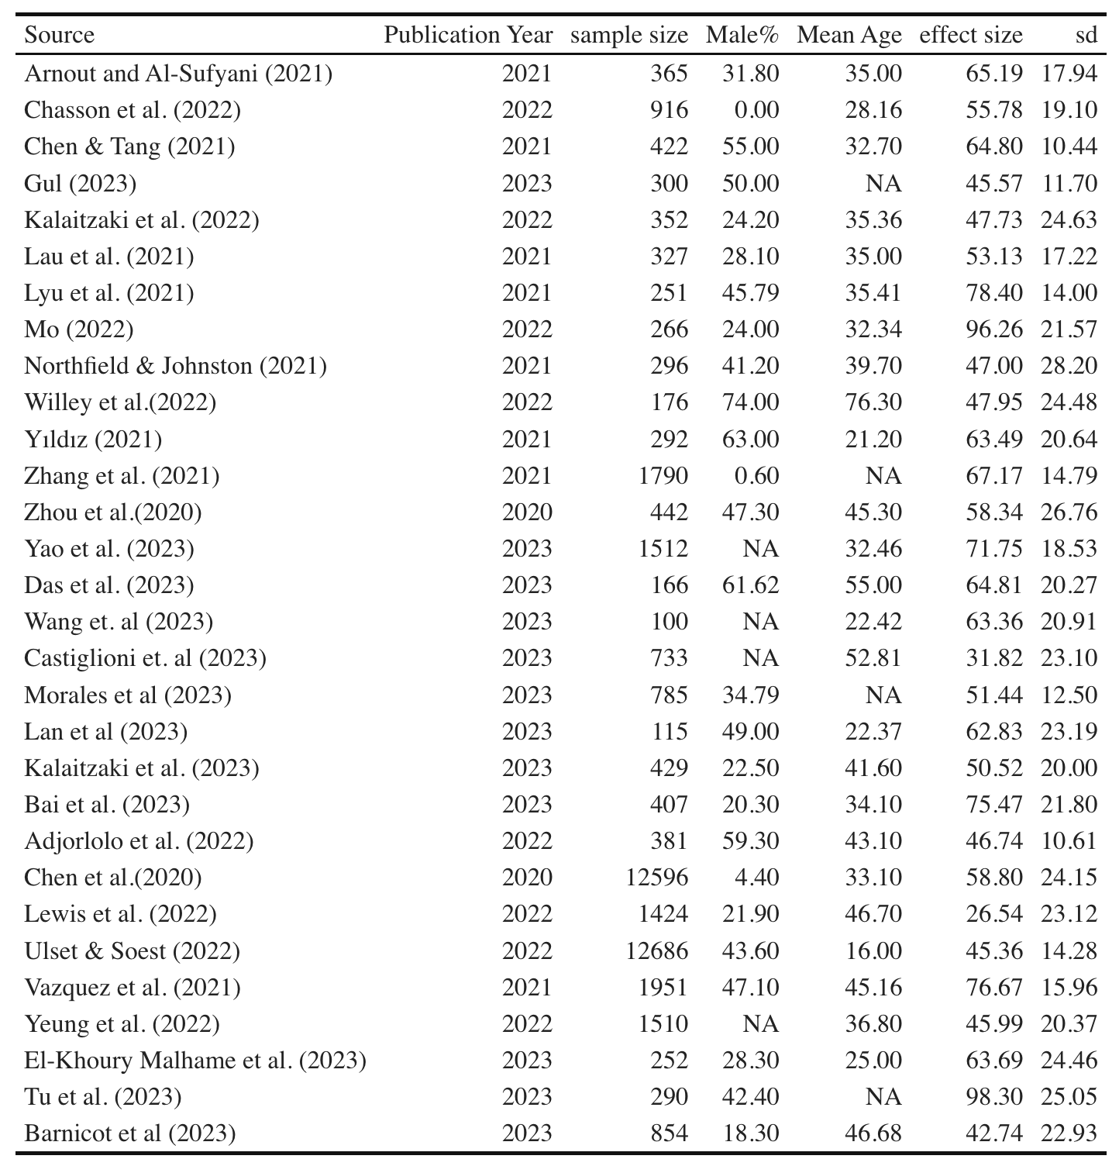

**Table 2: Statistical result of Main Analysis**

|  |  |  |  |  |  |  |  |
| --- | --- | --- | --- | --- | --- | --- | --- |
| **Random Effects Model (k=30)** | |  |  |  |  |  |  |
|  | Estimate | se | Z | p | CI Lower Bound | CI Upper Bound |  |
| Intercept | 0.75 | 0.15 | 4.92 | <.0001 | 0.45 | 1.05 |  |
| Heterogeneity Statistics | |  |  |  |  |  |  |
|  | Tau | Tau^2 | I^2 | H^2 | df | Q | p |
|  | 0.83 | 0.69 | 99.72% | 352.96 | 29 | 6174.90 | <.0001 |

**Figure 2 : Forest Plot of Main Analysis**

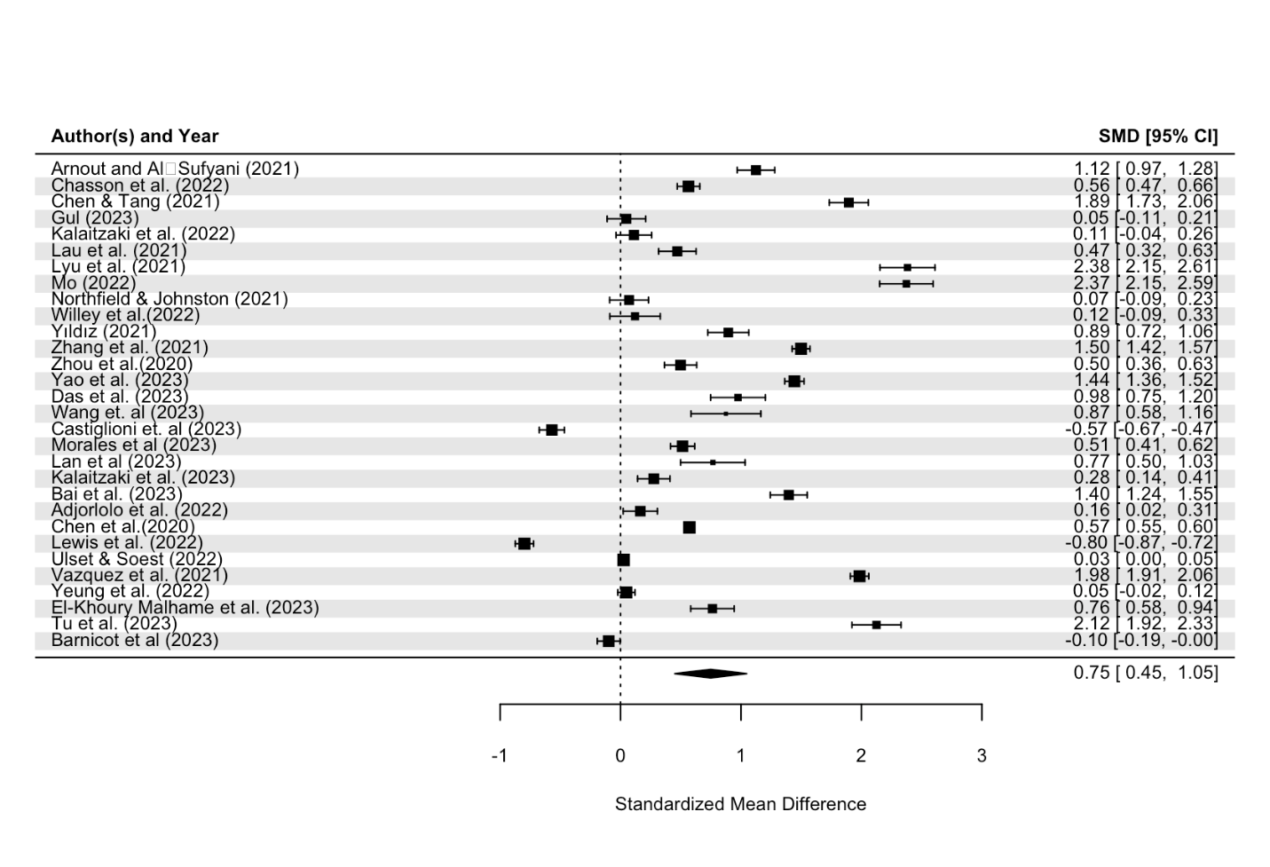

**Table 3:** Overview of the selected studies for subgroup analysis

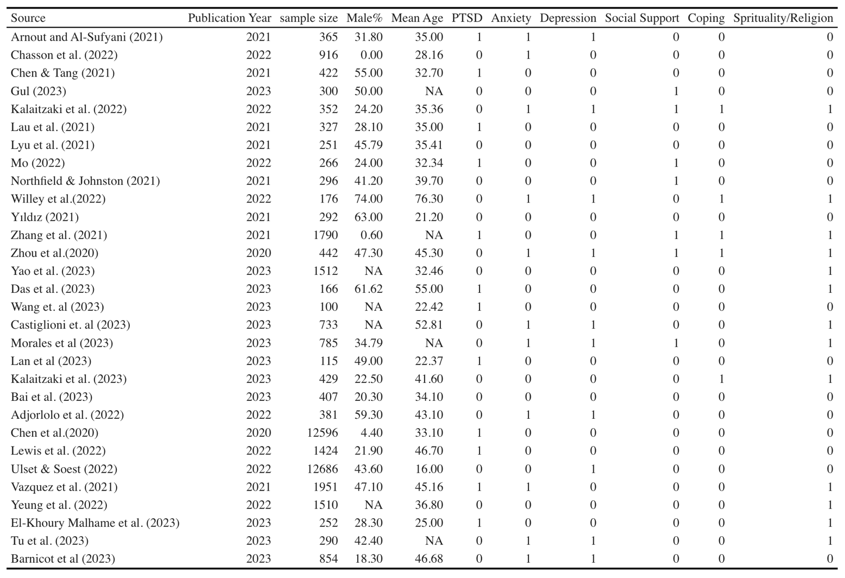

**Table 4: Results Summary of subgroup analysis**

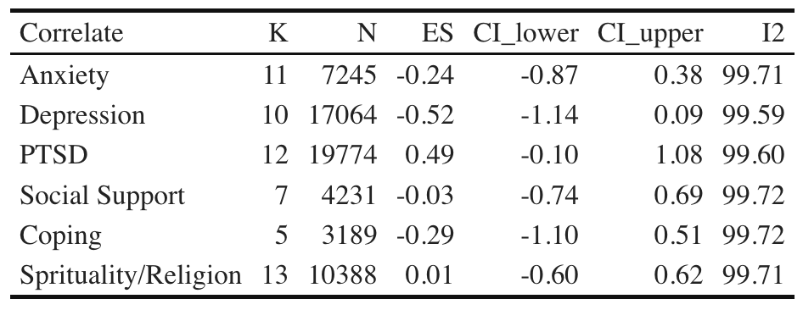

**Appendix**

**Figure 3: Forest plot for Depression related PTG among COVID-19 people**

**Methodological Heterogeneity across Studies**

In the final sample of studies, most studies used PTGI or its variations (e.g., SF, CPTGI), except one used SRGS-SF (Zhai_et_al.,2021). Despite the discrepancy in assessments, the link between CVD and PTG were compatible among studies. Thus, both scales on adulthood growth should be seen as usable in Covid-19 research. Given its wide usage in international studies, PTGI should be considered as a better choice in future clinical studies. Furthermore, the… For example, mean age of Chasson et al.’s (2022) study was 28.16, whereas Pietrzak et al.’ (2021) was 63.3. Both groups showed moderate or moderately high-level PTG (this may be modified based on subgroup analysis of age effects). Finally,

This diverse populations in these studies concerning age, race, cultural, and roles in the pandemic (e.g., patients, health providers, general populations). There was also the variation in when PTG was observed across 30 studies. The assessment time ranged from ?? month (??_et_al.,202?) to?? years (??_et_al.,202? QZ, replace them). Fifth, some studies did not specify the gender positively related to PTG. Sixth, Given the complicated relationship of PTG with PTSD and depression, two CVD mortality risks, it should be interesting to explore the likely intertwining trajectory of the three constructs in patients with CVD prognosis. Finally, we do not have enough effect size to test a PTG-PTSD relationship in PTG. …Most studies are cross-sectional in nature, hindering the statement of causality, even though and a cross-sectional design was included in previous meta-analyses (e.g., Stroup_et_al.,2000).

.

|  |  |  |  |  |  |  |  |
| --- | --- | --- | --- | --- | --- | --- | --- |
| Source | Year | Sample size | Male,% | Age (mean) | End Point | Follow up, y | Determinant |
| Ai et al. | 2013 | 262 | 60% | 62.4 | Cardiovascular diseases | 2.5 years | Depression, Coping, Spirituality, Social Support, Age, Gender |
| Garnesfski et al. | 2008 | 139 | 82% | 35-70 | Myocardial infarction | 3~12 months | Depression, Coping, Spirituality, Age, Gender |
| Hu et al. | 2020 | 65 | 70.80% | N/A (>18) | Stroke | 1 month | Depression, Spirituality, Social Support |
| Javed_&_Dawood | 2016 | 90 | 58% | 45-65 | Myocardial infarction | 1 month – 3 years | Coping, Social Support |
| Kelly et al. | 2017 | 43 | 58% | 74.53 | Stroke | 6 months | Coping, Social Support |
| Losiak_&_Nikiel | 2014 | 53 | 60.37% | 57.30 | Myocardial infarction | ~5.5 weeks | Coping, Spirituality |
| Magid et al. | 2019 | 52 | 69.20% | 64.80 | Cardiac disease | 43 months | Coping, Age |
| Overbaugh et al. | 2014 | 103 | 76% | 74 | Heart failure | N/A | Age, Gender |
| Rahimi et al. | 2016 | 166 | 84.9% | 55.3 | Myocardial infarction | ~7.78 months | Social support |
| Sheikh | 2004 | 110 | 79% | 63.5 | Heart disease | ~5 years | Coping. Social Support |
| Senol-Durak_&_Ayvasik | 2010 | 132 | 11.4% | 52.04 | Myocardial infarction | N/A | Depression, Coping, Social Support, Age, Gender |
| Gangstad_&_Norman et al. | 2009 | 60 | 56.67% | 71.67 | Stroke |  | Depression, Coping |
| Peng, Z. Y.,_&_Wan, L. H. | 2018 | 115 | 70.4% | 62.43 | Stroke | 6 months | Social Support |

|  |  |  |  |  |  |  |  |  |  |  |  |  |  |
| --- | --- | --- | --- | --- | --- | --- | --- | --- | --- | --- | --- | --- | --- |
| Source | Year | Sample Size | Male % | | Age (Mean) | | Endpoint | | Follow up, y | | PTG Mean | PTG SD | |
| Adjorlolo et al. | 2022 | 381 |  | 59.3 | | 43.1 | |  | | 3-months | | |  |
| Arnout_&_Al-Sufyani | 2021 | 365 |  | 31.8 | | n/a | |  | | n/a | | |  |
| Chasson et al. | 2022 | 916 |  | n/a | | 28.16 | |  | | n/a | | |  |
| Chen_&_Tang | 2021 | 476 |  | 55.50 | | 32.7 | |  | | January 20th | | |  |
| Chen et al. | 2020 | 12,596 |  | 4.40 | | 32.7 | |  | | n/a | | |  |
| Das et al. | 2023 | 166 |  | 61.62 | | 36.7 | |  | | n/a | | |  |
| Dominick_&_Elam | 2023 | 201 |  | 22.40 | | 35.39 | |  | | 4/30/20-9/30/20 | | |  |
| El-Khoury Malhame et al. | 2023 | 252 |  | 71(28.3) | | 25.00 | |  | | n/a | | |  |
| Gul | 2023 | 300 |  | 50 | | n/a | |  | | n/a | | |  |
| Kalaitzaki et al. | 2022 | 1,361 |  | 24.2,17.3 | | 35.36 | |  | | Second Lockdown | | |  |
| Lan et al. | 2023 | 115 |  | 49 | | 22.37 | |  | | February-April 2020 | | |  |
| Lau et al. | 2021 | 327 |  | 28.10 | | 35 | |  | | 4/24/20-5/12/20 | | |  |
| Lewis et al. | 2022 | 1,424 |  | 21.90 | | 46.7 | |  | | November 20th | | |  |
| Lyu et al. | 2021 | 535 |  | 45.79 | | 35.41 | |  | | May 20th | | |  |
| Mo | 2022 | 266 |  | 24 | | 32.34 | |  | | n/a | | |  |
| Morales et al. | 2023 | 891 |  | 310 | | n/a | |  | | n/a | | |  |
| Northfield_&_Johnston | 2021 | 296 |  | 41.20 | | 39.7 | |  | | n/a | | |  |
| Pietrzak et al. | 2021 | 7,860 |  | 91.60 | | 63.3 | |  | | 11/9/20-12/19/20 | | |  |
| Prieto-Ursua_&_Jodar | 2020 | 1,091 |  | 30.60 | | n/a | |  | | n/a | | |  |
| Tu et al. | 2023 | 290 |  | 123 | | 25-29 | |  | | n/a | | |  |
| Ulset_&_Soest | 2022 | 12,686 |  | 43.6 | | n/a | |  | | n/a | | |  |
| Vazquez et al. | 2021 | 1,951 |  | 918 | | 45.16 | |  | | n/a | | |  |
| Wang et al. | 2023 | 100 |  | n/a | | 22.42 | |  | | n/a | | |  |
| Willey et al. | 2022 | 176 |  | 74 | | 76.3 | |  | | n/a | | |  |
| Yao et al. | 2023 | 1,512 |  | 6.20 | | 32.46 | |  | | n/a | | |  |
| Yeung et al. | 2022 | 1,510 |  | n/a | | 36.8 | |  | | September 20th | | |  |
| Yildiz | 2021 | 292 |  | 63 | | 21.20 | |  | | n/a | | |  |
| Zhai et al. | 2021 | 423 |  | 157 | | 24.96 | |  | | n/a | | |  |
| Zhang et al. | 2021 | 1,790 |  | 11 | | n/a | |  | | n/a | | |  |
| Zhou et al. | 2020 | 1,021 |  | 47.31 | | 45.3 | |  | | 5/4-5/8, 5/18-5/22 | | |  |

|  |  |  |  |  |  |  |
| --- | --- | --- | --- | --- | --- | --- |
| **Correlate** | **K** | **N** | **ES** | **95% CI lower** | **95% CI upper** | **I2** |
| Depression | 5 | 658 | -0.15 | -0.41 | 0.11 | 91.96% |
| Coping Strategies | 9 | 941 | 0.50 | 0.33 | 0.66 | 93.04% |
| Spirituality | 4 | 519 | 0.56 | 0.38 | 0.75 | 89.38% |
| Social Support | 8 | 983 | 0.29 | -0.05 | 0.62 | 98.25% |
| Age | 5 | 688 | 0.04 | -0.12 | 0.20 | 78.49% |
| Gender | 4 | 636 | 0.10 | 0.03 | 0.18 | 11.01% |